Using sar2xls(x) to create an xls or xlsx formatted spreadsheet from a sar text file

The Perl scripts sar2xls and sar2xlsx can be used to create an xls or xlsx formatted Excel spreadsheet from a sysstat sar text output file (note: not the sar binary data file).

Installing sar2xls
The script sar2xls uses the Perl Spreadsheet::WriteExcel module to create the spreadsheet, and thus can be used from OS X, Windows or Linux as long as this and its required Perl modules are installed:

- OLE-Storage_Lite
- Parse-RecDescent
- Spreadsheet-WriteExcel

Installing sar2xls on Red Hat Enterprise Linux 6
The pre-requisite Perl modules are in the EPEL repository (http://fedoraproject.org/wiki/EPEL). Once the EPEL repository is added to your Red Hat Enterprise Linux 6 system, these Perl modules can be installed with the single command:

yum install perl-Spreadsheet-WriteExcel
Now download the sar2xls file from https://github.com/pemcg/sar2xls and copy it to a directory on your $PATH, or to a local working directory.

Installing sar2xls on Windows
Download and install the appropriate ActivePerl MSI installer bundle for the running version of Windows from http://www.activestate.com/activeperl/downloads
If required, set the http_proxy variable in accordance with http://docs.activestate.com/activeperl/5.10/faq/ActivePerl-faq2.html#ppm_and_proxies
Then from a command prompt:
ppm install Spreadsheet-WriteExcel
Now download the sar2xls file from https://github.com/pemcg/sar2xls and copy it to a directory on your $PATH, or to a local working directory.

Installing sar2xls on Mac OS X
The pre-requisite Perl modules are available from CPAN. Its recommended to set FTP into passive mode so as to avoid having any troubles due to CPAN not being able to download from repositories via ftp.

export FTP_PASSIVE=1
Then to run CPAN (as root):

sudo perl -MCPAN -e "shell"
cpan[1]> install Spreadsheet::WriteExcel

Now download the sar2xls file from https://github.com/pemcg/sar2xls and copy it to a directory on your $PATH, or to a local working directory.

Installing sar2xlsx
The script sar2xlsx uses the Perl Excel::Writer::XLSX module to create the spreadsheet, and thus can be used from OS X, Windows or Linux as long as this is installed.

Installing sar2xlsx on Red Hat Enterprise Linux 6
The pre-requisite Perl modules are in the EPEL repository (http://fedoraproject.org/wiki/EPEL). Once the EPEL repository is added to your Red Hat Enterprise Linux 6 system, these Perl modules can be installed with the single command:

yum install perl-Excel-Writer-XLSX
Now download the sar2xls file from https://github.com/pemcg/sar2xls and copy it to a directory on your $PATH, or to a local working directory.

Installing sar2xlsx on Windows
Download and install the appropriate ActivePerl MSI installer bundle for the running version of Windows from http://www.activestate.com/activeperl/downloads
If required, set the http_proxy variable in accordance with http://docs.activestate.com/activeperl/5.10/faq/ActivePerl-faq2.html#ppm_and_proxies
Then from a command prompt:
ppm install Excel-Writer-XLSX
Now download the sar2xlsx file from https://github.com/pemcg/sar2xlsx and copy it to a directory on your $PATH, or to a local working directory.

Installing sar2xlsx on Mac OS X
The pre-requisite Perl modules are available from CPAN. Its recommended to set FTP into passive mode so as to avoid having any troubles due to CPAN not being able to download from repositories via ftp.
export FTP_PASSIVE=1
Then to run CPAN (as root):

sudo perl -MCPAN -e "shell"
cpan[1]> install Excel::Writer::XLSX

Now download the sar2xlsx file from https://github.com/pemcg/sar2xls and copy it to a directory on your $PATH, or to a local working directory.

Usage
The usage of both scripts is the same:

usage: sar2xls(x) [-f sar_file | -a] [-t threshold_file] [-D directory] [-b begin_time -e end_time] [-o output_file] [-m] [-V]

Where:
-V prints the version of sar2xls
-f Specifies the sar text file to process (excluding the directory path)
-a Specifies all sar files in current or specified folder
-t Optional threshold file for colour-coding cells
-D Optional directory to use for input and output (default is the current directory)
-b Begin Time
-e End Time
-m Indicates to break out per-CPU stats rather than the average for all CPUs
-o Specifies an optional output file name (default is hostname-date)

e.g. sar2xls(x) -f sar05 -D /path/to/sarfile -b 10:22:30 -e 10:45:00
sar2xls(x) -a -D /var/log/sa

Note that -f and -a are mutually exclusive: -a will recognise and process all sar files in the specified (or default) directory.

Time Slices

If we only wish to examine a particular time interval in the sar file, we can specify this using the begin and end (–b and –e) switches, i.e.

sar2xls(x) -f sar_file -b 13:30:00 –e 14:00:00

Thresholds File

An optional threshold file can be specified on the command line, and is used to specify values to watch for, and colour-code a cell accordingly, i.e.

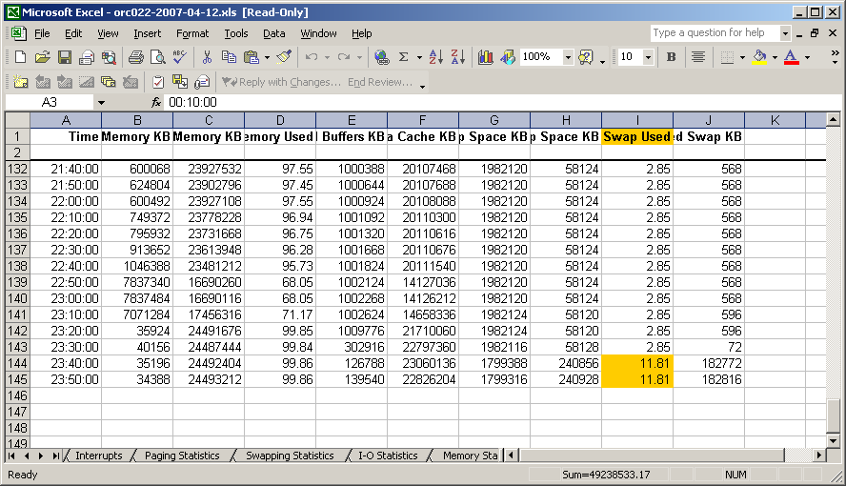

The file is formatted as follows:

[Amber]
parameter=value
parameter=value
[Red]
parameter=value
parameter=value
…

i.e.

[Amber]
%utilisation=50
rd_sec/s=61035
wr_sec/s=61035
%swpused=10
[Red]
%utilisation=70
rd_sec/s=122070
wr_sec/s=122070
%swpused=30

Each parameter should be specified exactly as it appears in the sar file, and the value can be positive or negative to specify a maximum or minimum value. Comment lines starting with a # or blank lines are ignored.

i.e.

%utilisation=50

would flag when CPU utilisation rose above 50%, and

kbmemfree=-10000

would flag when free memory sank below 10000KB

Device Mapping File
By default sar uses device major,minor IDs to identify devices in the device I/O section:

00:10:01 dev8-224 0.87 0.53 6.40
00:10:01 dev8-240 0.87 0.53 6.40
00:10:01 dev65-0 25.31 201.33 0.50
00:10:01 dev2-0 0.00 0.00 0.00
00:10:01 dev9-0 0.00 0.00 0.00
00:10:01 dev253-0 0.34 0.00 2.75
00:10:01 dev253-1 13.73 0.03 109.77
00:10:01 dev253-2 0.15 0.13 1.17
00:10:01 dev253-3 2.42 0.05 19.32
00:10:01 dev253-4 0.00 0.00 0.00
00:10:01 dev253-5 0.06 0.12 0.47
00:10:01 dev7-0 0.00 0.00 0.00
00:10:01 dev7-1 0.00 0.00 0.00

which can make it quite difficult to identify which actual device the statistics are referring to. sar2xls(x) will use an (optional) per-system device name mapping file if found in the current working directory, to map the major,minor device name to something more meaningful. The mapping file name must be `hostname -s`_dev_map, i.e. xxx020_dev_map, and the format of the mapping file is an follows:

[hostname]
dev10-63 = mapper~control
dev253-0 = mapper~VolGroup00-LogVol02
dev253-1 = mapper~VolGroup00-LogVol01
dev253-2 = mapper~VolGroup00-LogVol00
dev8-0 = dev~sda
dev8-1 = dev~sda1
dev8-16 = dev~sdb
dev8-17 = dev~sdb1
dev8-2 = dev~sda2
dev9-0 = dev~md0
…

If the mapping file is found, sar2xls(x) will translate device names according to the entry in the mapping file, i.e.

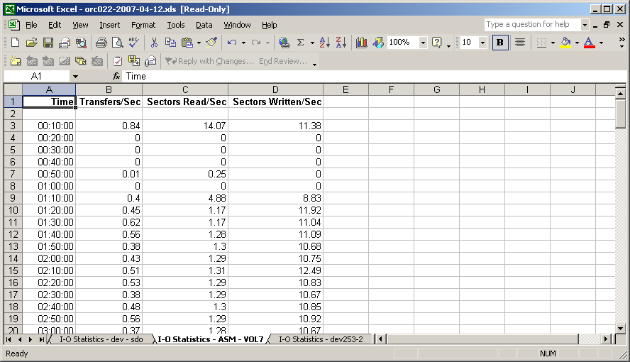

Unfortunately Excel does not permit ‘/’ characters in the names of worksheets, so “/dev/sda” would not be allowed. Use something meaningful like dev~sda instead.

A mapping file can be created using the mk_dev_map.pl script

